CSC501: Module 6 – Project Milestone
11/17/2024
Nathan Rogers

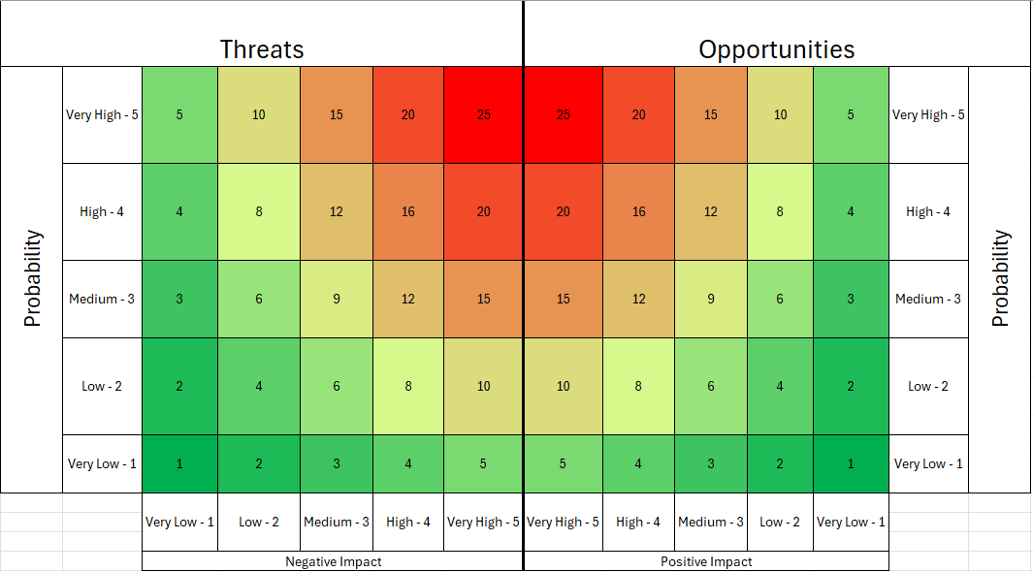
Project Risk
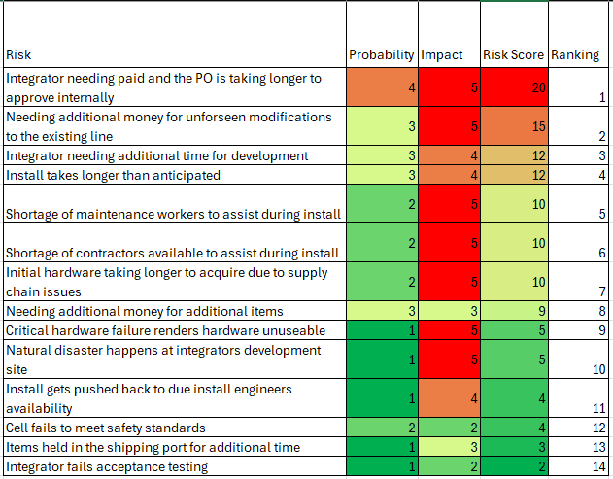
Addressing ranking number one, this has been an issue at Vitro for as long as I have been working on projects. The bureaucracy of everyone needing to approve the Purchase Order (P.O.) instead of just the people who need to definitely needs to change. This has the most likelihood of happening as it happens for almost every project. I’ve seen a project delayed due to this issue for 1-2 months because it is sitting in someone’s approval inbox and doesn’t do anything with it. This also has the highest impact as this could delay the entire project. Most integrators will not start working unless they have a down payment on the project and the rest is due upon installation. If they don’t get the initial payment in a timely manner, we could lose the spot for them to start programming and developing to a different project because the other project came through with their down payment. I have unfortunately seen this happen.
When a project comes to needing additional time and or money to complete can happen and is on average on the lower side. However, if they do happen it can cause the project to halt for a time and push back the timeline as we will need to present the project changes and why they happened at an additional gate review. This gate review includes all major decision-making stakeholders who can approve additional funds being released or not. Sometimes the integrators will continue and add it to the final bill, and some won’t until confirmation and proof of additional funds have been allocated to the project.
The shortage of people has historically not been a problem but has been in recent months. We are in the midst of an installation right now and we are having trouble finding contractors and local maintenance assistance. This issue has unfortunate timing with this installation as this can fluctuate with the market but overall, this has a lower chance of happening usually during installations.
Natural disasters can happen but almost never occur to an extent that they interfere with a project. I say almost never because the COVID-19 virus during 2020 and 2021 did indeed disrupt everything from supply chain to working on projects at all. Hopefully, natural disasters continue to play a very small to non-existent role on projects.
The least likely and least impactful are based upon looking back at past projects. Even though they are least likely and the least impactful to the project doesn’t make them any less important to consider. Integrators are very good at making sure everyone is well protected and safe when working around and on robotic cells. Vitro also does a good job at making sure safety concerns are addressed from the start. Historically, items usually clear customs quickly and arrive at our facilities in a timely manner due to paperwork being filed correctly. Finally, even if an integrator fails to meet all criteria at acceptance testing, they are quick at turning around changes that will render the cell within all specifications.

